Austin Pena (est892)  
CS 5103  
5/3/2021

Tool Application Report for Word Statistics Project

The SonarQube tool was downloaded and used exactly as described in the class lecture:

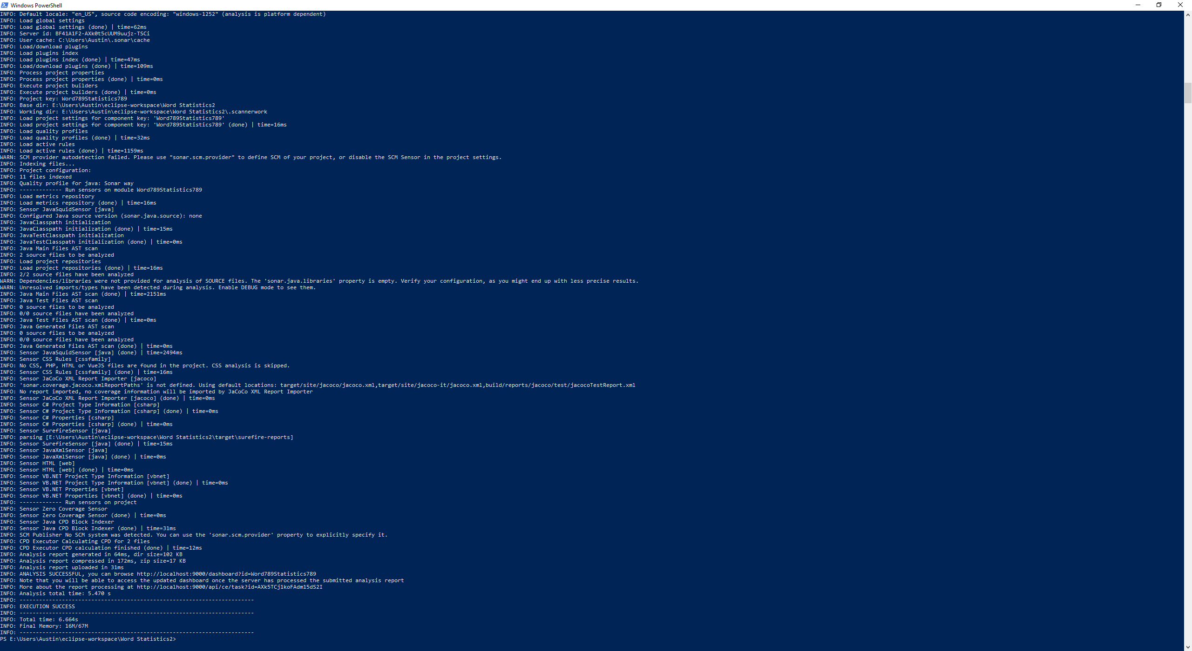

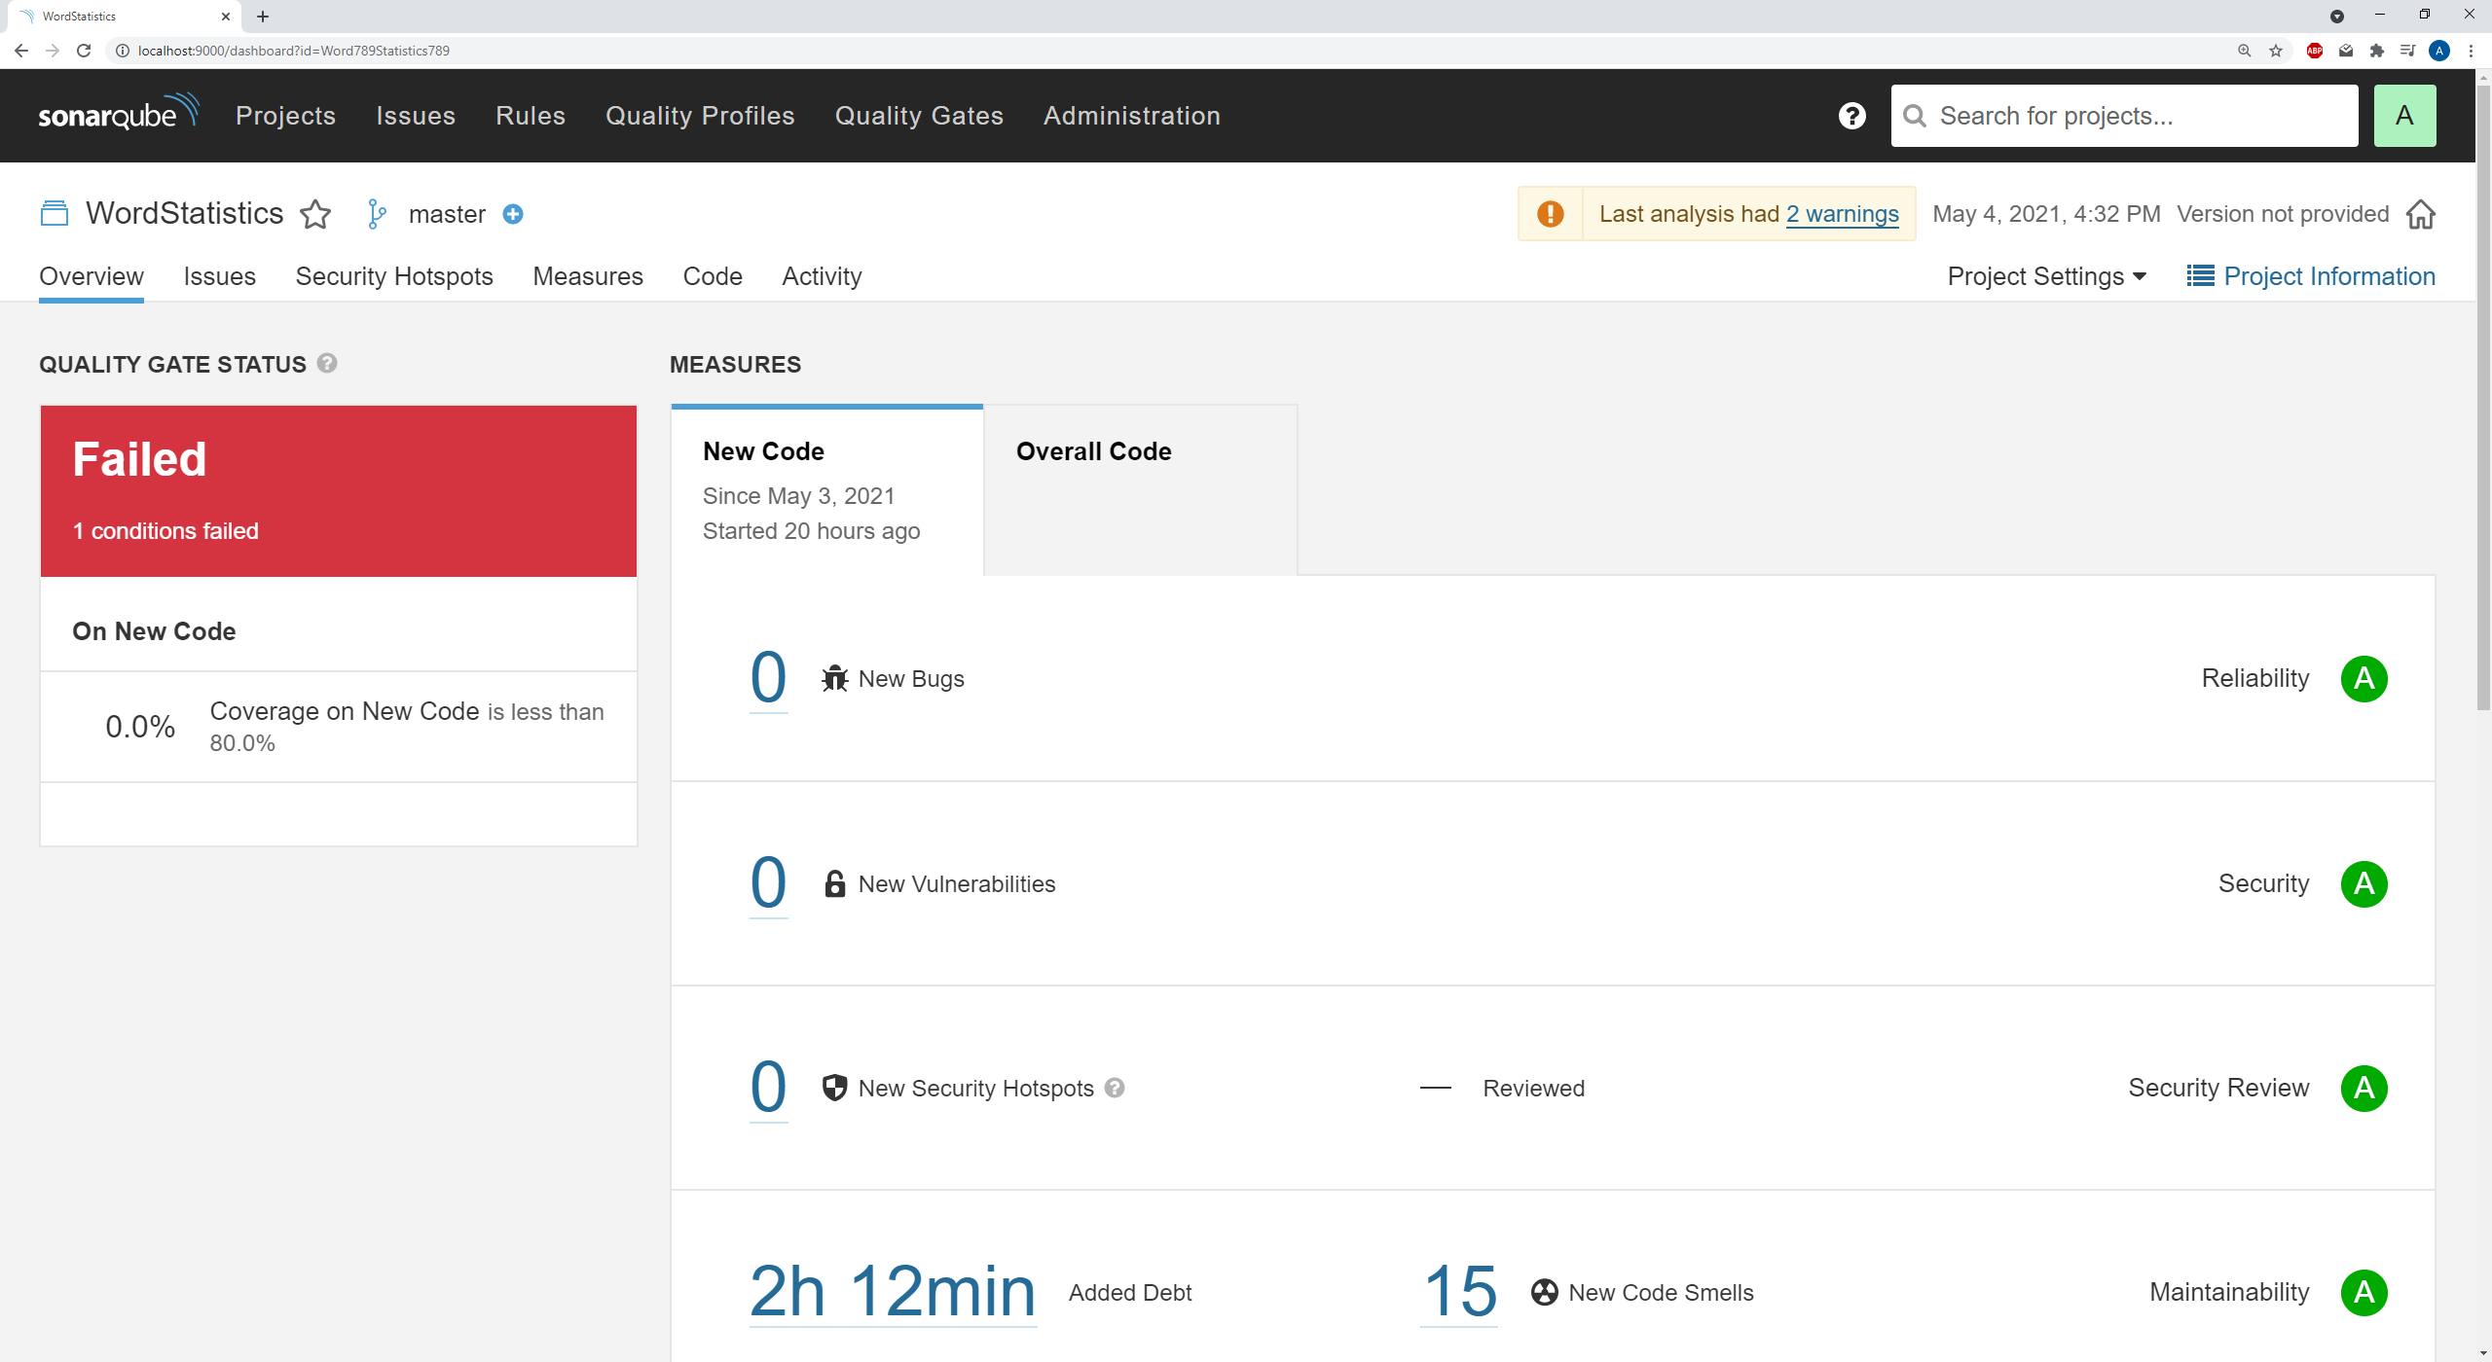

The only interesting problem I had in this process was that the scans would fail, because my storage drive was too close to being full. I had to troubleshoot that problem, then uninstall a VR app to make room.

Code Clone Detection

The tool did not detect any duplicated lines:

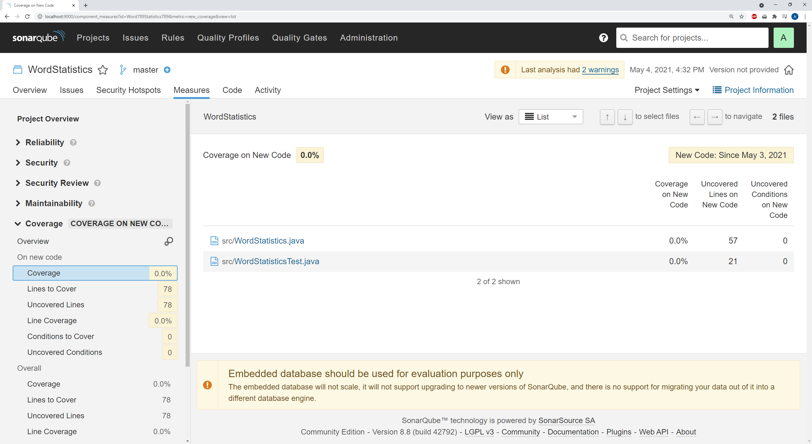

This outcome is a bit interesting, because some lines of code are identical. For instance, two lines are exactly “SCNR = new Scanner(file);”. However, SonarQube was apparently smart enough to recognize that these lines were not part of erroneous code duplication.

Static Bug Detection

This tool did not find a bug with the latest version:

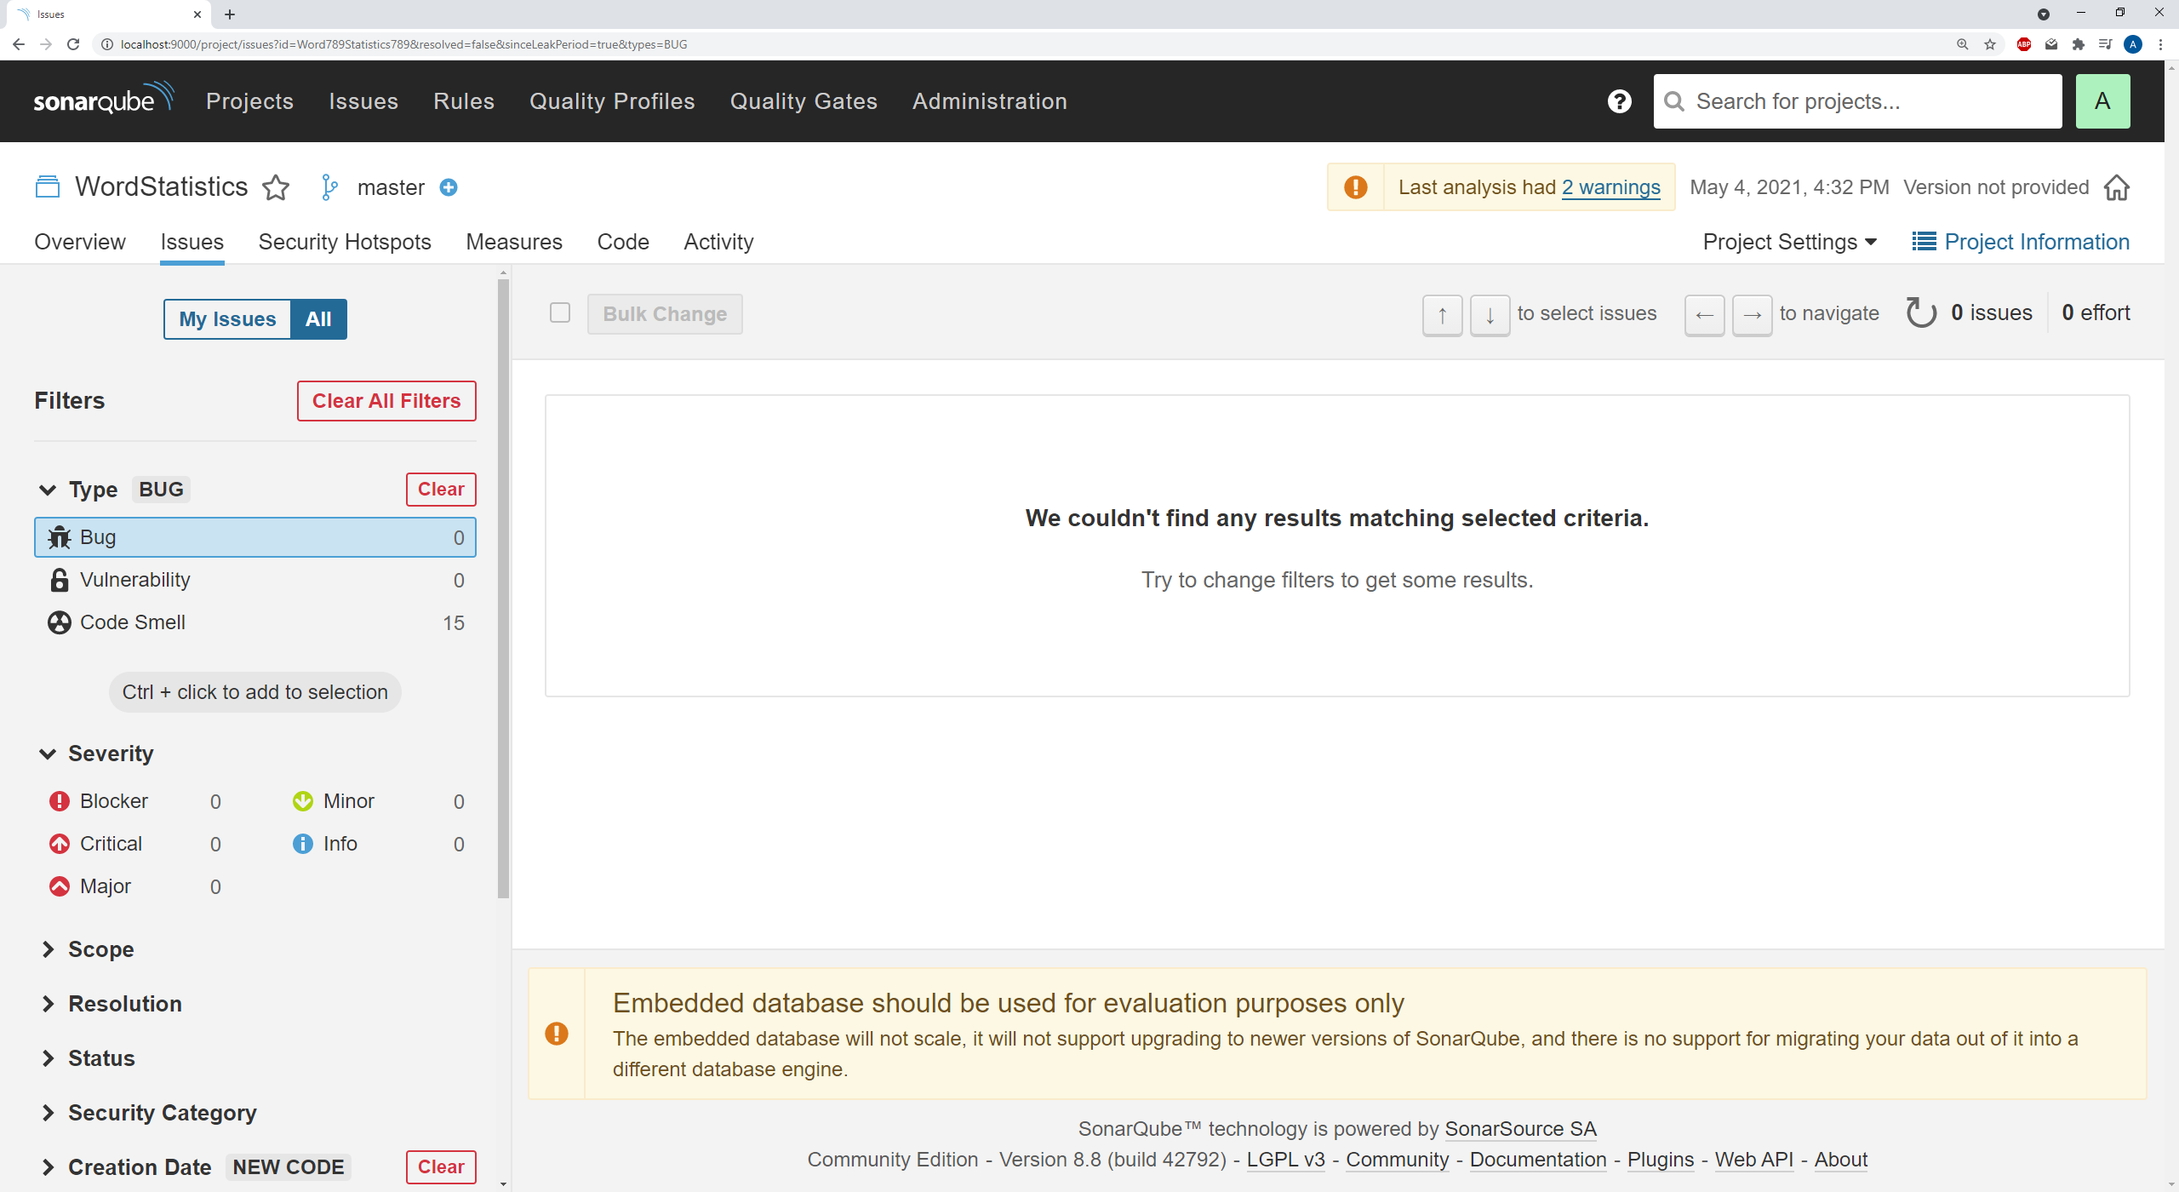

At one point, the tool declared there was a bug: I closed the Scanner in the “Try” and “Catch” blocks of code, when it would be simpler and safer to just close the Scanner in the “Finally” section. It no longer mentions this bug, even though I did not fix it. Either way, I agree that it would be more efficient to only close the scanner in the finally block, but I left the code as-is because I wanted the tool to report the bug.

The scanner did report 15 code smells, but none seemed applicable to the actual project:

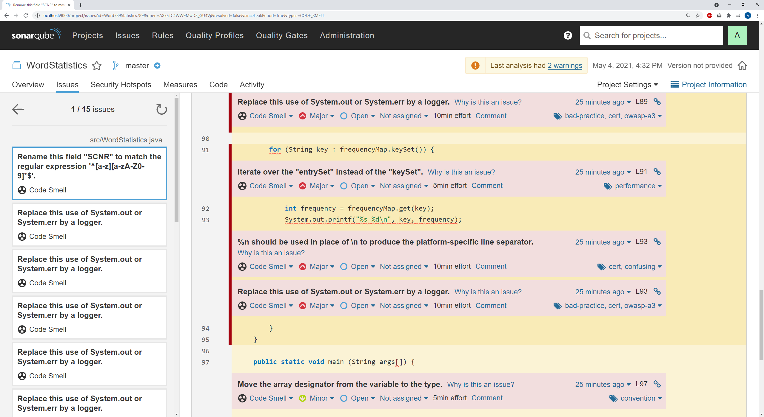

For instance, the tool would tell me to use a logger instead of System.out, and use “%n” instead of “\n”. These suggestions seemed very unnecessary for this project, though I could see how these suggestions may be important on a bigger project..